Тема уроку : Я, моя родина, мої друзі.
Зовнішність людини

Цілі уроку :
- удосконалювати навички вживання лексичних одиниць по темі “Зовнішність людини”;
- розвивати навички аудіювання й усного мовлення з теми;
- виховувати правильне ставлення до людської зовнішності, а також загальну культуру учнів.

Очікуваний результат на кінець уроку:
- висловлювати і обґрунтовувати власну думку, погляди, почуття щодо зовнішності людини;
- розуміти ключову та детальну інформацію в аудіотексті;
- навчитися працювати самостійно та в парах.

Обладнання : підручник Get 200 Book 1, картки з завданнями ,телевізор, ноутбук.

Схематичний план уроку

- Початок уроку. Організація класу. Повідомлення цілей уроку. – 3 хв.
- Уведення в іншомовну атмосферу – 7 хв.
- Перегляд тематичного відео та виконання завдань – 12 хв.
- Лексична гра «Вгадай хто?» - 15 хв.
- Пояснення домашнього завдання. – 2 хв.
- Підсумки уроку. – 1 хв.

Хід уроку

1.Початок уроку. Організація класу. Повідомлення цілей уроку.
Т.: Good morning dear pupils! I hope you are all in a good mood today! How are you?
Ss answer the question…
T.: If you are not fine, I am going to raise your spirits with a funny game, an amusing video and an interesting discussion about the variety of people’s appearances. We are going to listen and talk about different views on appearance and its influence on your life.

2. Уведення в іншомовну атмосферу.
T.: Do you like to play a game Wordsearch? Let’s play it now! Work in pairs and find 13 words describing parts of the body, either across or down. The first pair of students will be nominated as BEST WORDS EXPERTS!
C | E | L | B | O | W | A
H | T | I | A | E | N | R
I | O | P | C | Y | A | M
N | E | C | K | E | I | H
I | H | A | N | K | L | E
K | C | H | E | S | T | E
C | H | E | E | K | A | L

Ss work in pairs, find and write down the words into their copy-books, then the first pair read out their list of words.
3. Перегляд тематичного відео та виконання завдань .
T.: It’s high time to listen to a poem of the outstanding Shakespeare! You will watch and listen to sonnet 130 recited by famous British actor and fill in the missing words in the worksheets given to you, check the words in pairs and practice reading the poem to each other!
Students’ worksheet
My mistress' _____ are nothing like the sun;
Coral is far more red than her ____ red;
If snow be white, why then her ______ are dun;
If ______ be wires, black wires grow on her head.
I have seen roses damasked, red and white,
But no such roses see I in her_______ ,
And in some perfumes is there more delight
Than in the ______ that from my mistress reeks.
I love to hear her______ , yet well I know
That music hath a far more pleasing sound;
I grant I never saw a goddess go -
My mistress when she ______ treads on the ground.
And yet, by heaven, I think my love as rare
As any she belied with false compare.

Teacher’s worksheet
My mistress' eyes are nothing like the sun;
Coral is far more red than her lips' red;
If snow be white, why then her breasts are dun;
If hairs be wires, black wires grow on her head.
I have seen roses damasked, red and white,
But no such roses see I in her cheeks;
And in some perfumes is there more delight
Than in the breath that from my mistress reeks.
I love to hear her speak, yet well I know
That music hath a far more pleasing sound;
I grant I never saw a goddess go;
My mistress, when she walks, treads on the ground.
And yet, by heaven, I think my love as rare
As any she belied with false compare.

Ss watch the video (https://www.youtube.com/watch?v=9EZbxl-u0Hc), work on their own, then in pairs.
T.: And now let’s hold a competition BEST POEM RECITER!!! (students read out the sonnet and decide who the best is).
4. Лексична гра «Вгадай хто?»
T.: Let’s zoom in the world of famous people and their extraordinary appearances. You will play a game “Guess who ?”.
Ss split into pairs and sit face to face, the teacher shows the photos of famous people and a student sitting with his back to the teacher asks for 2 minutes another student sitting with his face to the teacher different questions trying to guess the celebrity).

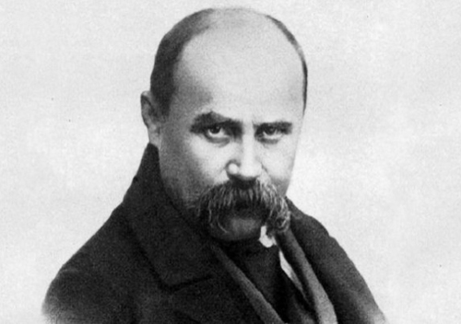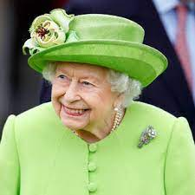
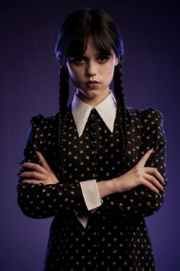
Sample questions
- Is it a man or a woman?
- Is he/she from Ukraine or abroad?
- What country is he/she from?
- Is he/she a politician/an actor/a singer and so on?
- Is he/she old or young or middle-aged?
- Is he/she tall or short?
- Is he/she slim or overweight?
- What hair has he/she got?
- Has he/she got any distinguishing features?
- What clothes does he/she usually wear?

6. Пояснення домашнього завдання.
T.: Our today’s work was not in vain. Use it in your homework: your school magazine has asked its readers to send in articles describing the most eccentric person you have ever met.

7. Підсумки уроку.
T.: Thank you for your active work, your marks for today are … . And remember that - beauty is in the eye of the beholder!!!

